**PHONEBOOK USER MANUAL**

The number of contacts saved in the phonebook is displayed for you at the top of the screen followed by the Menu

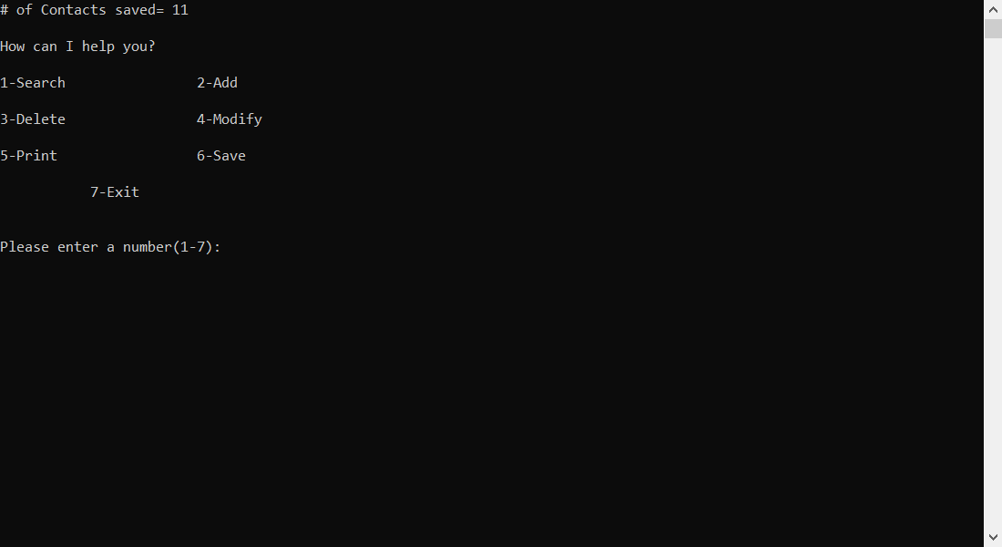

**To Search for an existing contact:**

- Press (1)

-Enter the last name of the contact you want to search for

-Contact/s will be displayed and the program will tell you how many contacts have the same last name

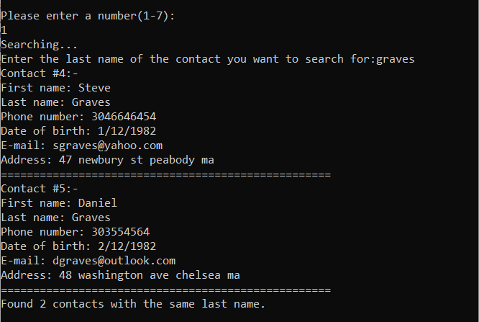

**To Add a new Contact to the Phonebook:**

-Press (2)

-Enter the First name, Last name, day of birth, month of birth, year of birth, e-mail, address, and phone number

-If any entry is Invalid the program asks you to enter a Valid one

-Program shows that the contact is added and asks you to save this contact in the phonebook by pressing (6)

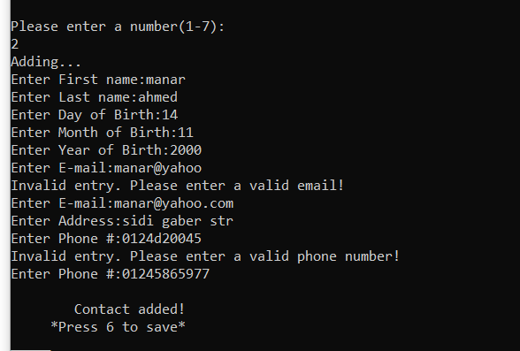

**To Delete an existing contact:**

-Press (3)

-Enter the First name of the contact you want to delete

- Enter the Last name of the contact you want to delete

-Program displays the contact and asks to make sure if this is the contact you want to delete

-Press (1) if you want to delete, Program shows that the contact is deleted and asks you to save this change

-Press (2) if you don’t want to delete the contact

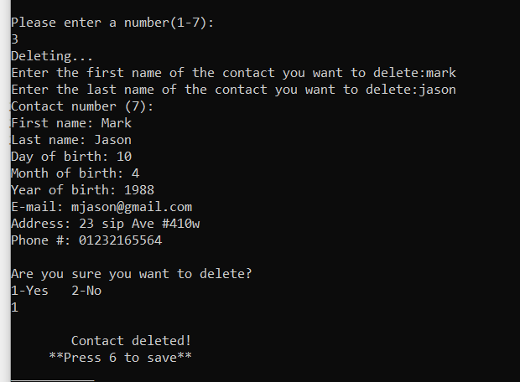

**To Modify an Existing Contact:**

-Press (4)

-Type the Last name of the contact you want to modify

-Contact/s with the same Last name will be displayed. If more than one contact is shown the program asks you to choose the contact by pressing the contact number of the contact you want to modify.

-Press (1) if you want to modify the given part of the contact or press (2) if you don’t want to modify this part

--If you Press (1) type in the modified part. If any entry is Invalid the program asks you to enter a Valid one

- Program shows that the contact is modified and asks you to save this change in the phonebook by pressing (6)

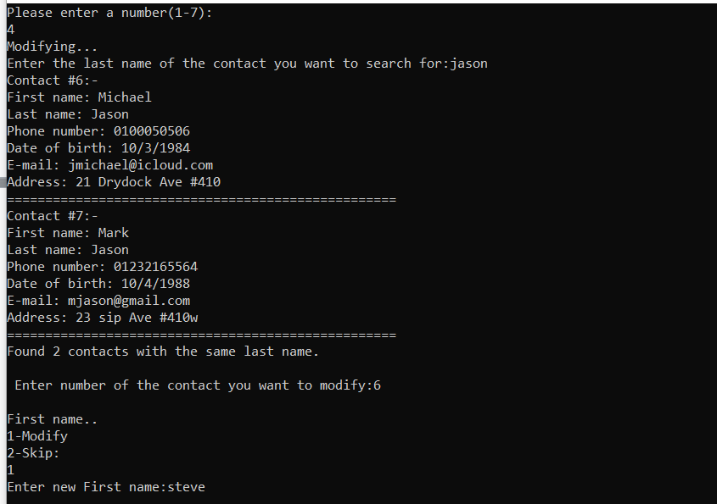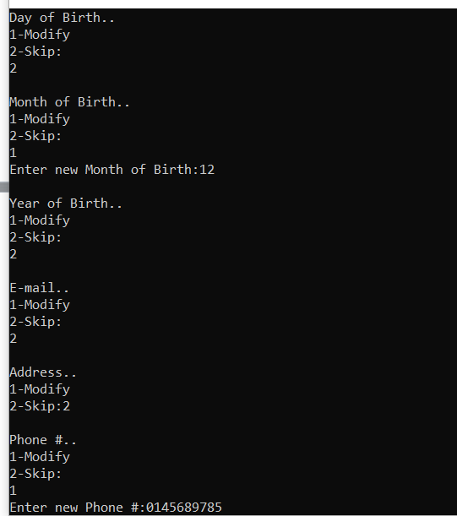

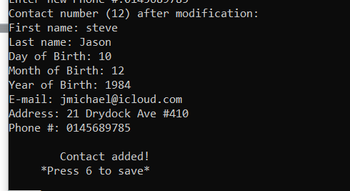

**To Print the contacts in your Phonebook:**

-Press (5)

-Press (1) if you want to print the contacts alphabetically

-Press (2) if you want to print the contacts by date of birth from eldest to youngest

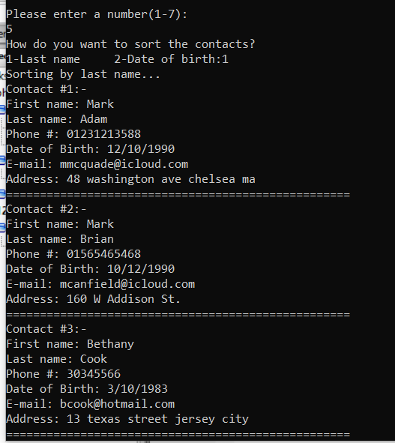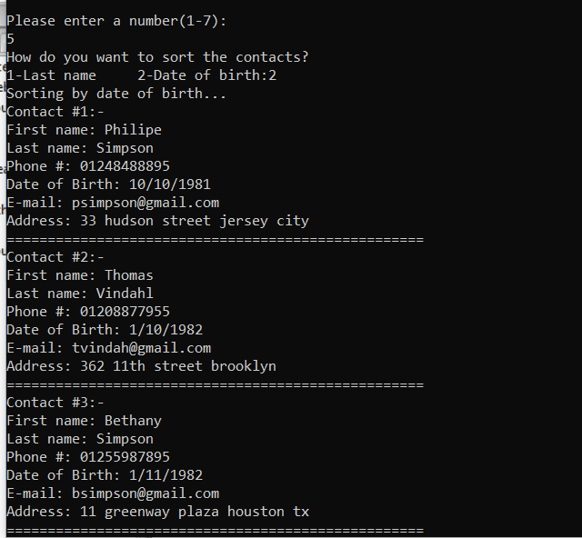

**To Save Changes made in the phonebook:**

-Press (6)

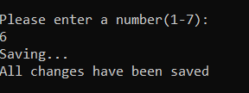

**To Exit the program:**

-Press (7)

-Press (1) to confirm exiting the program

-Press (2) if you still want to continue in the program

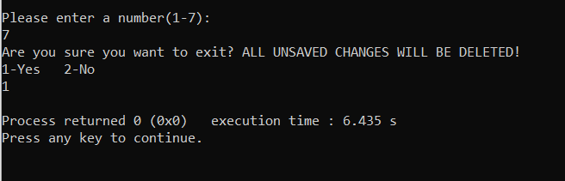

**Algorithms used in the making of this program:-**

-Sorting Algorithm:

The Bubble Sort algorithm was used in our program in Print function to go over the contacts repeatedly and swap them until they are sorted how the user chooses (alphabetically or by age).

-Search Algorithm:

The Linear Search algorithm was used in our program in the Search function comparing each contact with the following contact until the wanted contact is found or the list ends and gives its location. This is also known as Sequential search.